User ID Controlled by Request Parameter (Unpredictable User IDs)
Platform: PortSwigger Web Security Academy
Lab Level: Apprentice
Lab Name: User ID controlled by request parameter, with unpredictable user IDs
Category: Access Control / Horizontal Privilege Escalation
Author: Chamika Jayasooriya
Field: Cybersecurity / Penetration Testing
Date:

1. Introduction
This document presents a professional security lab write-up for the “User ID controlled by request parameter, with unpredictable user IDs” lab from the PortSwigger Web Security Academy. The lab demonstrates a horizontal privilege escalation vulnerability where user accounts are identified using GUIDs (Globally Unique Identifiers) instead of sequential IDs.
Although GUIDs are difficult to guess, the application fails to properly enforce server-side authorization checks, allowing attackers to access sensitive information belonging to other users once a valid GUID is discovered.

2. Lab Objective
The objectives of this lab are:
- Log in as a normal user
- Identify another user’s GUID (Carlos)
- Manipulate the request parameter to access another user’s account
- Retrieve and submit Carlos’s API key

3. Vulnerability Overview

3.1 Vulnerability Type
- Broken Access Control
- Horizontal Privilege Escalation

3.2 Description
The application uses a GUID to identify users in the account page URL. While GUIDs are designed to be unpredictable, they do not provide security by themselves. If an attacker obtains another user’s GUID through publicly accessible content, they can manipulate request parameters to access unauthorized data.

4. Tools & Environment
- Web Browser (Chrome / Firefox)
- PortSwigger Web Security Academy Lab Environment
- Optional: Burp Suite (for request inspection)

5. Test Accounts Used
Username | Password | Role
wiener | peter | Normal User
carlos | Unknown | Normal User

6. Step-by-Step Exploitation

Step 1: Identify a Blog Post by Carlos
Browse the application and locate a blog post authored by Carlos.
📸 Screenshot 1: Blog post authored by Carlos
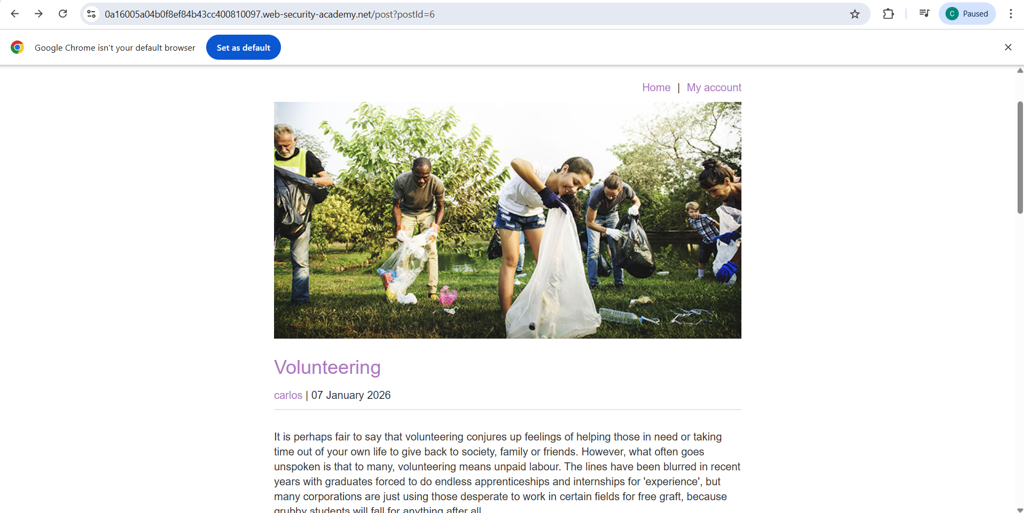

Step 2: Extract Carlos’s User ID (GUID)
Click on Carlos’s username and observe that the URL contains a GUID identifying his account. Save this GUID for later use.
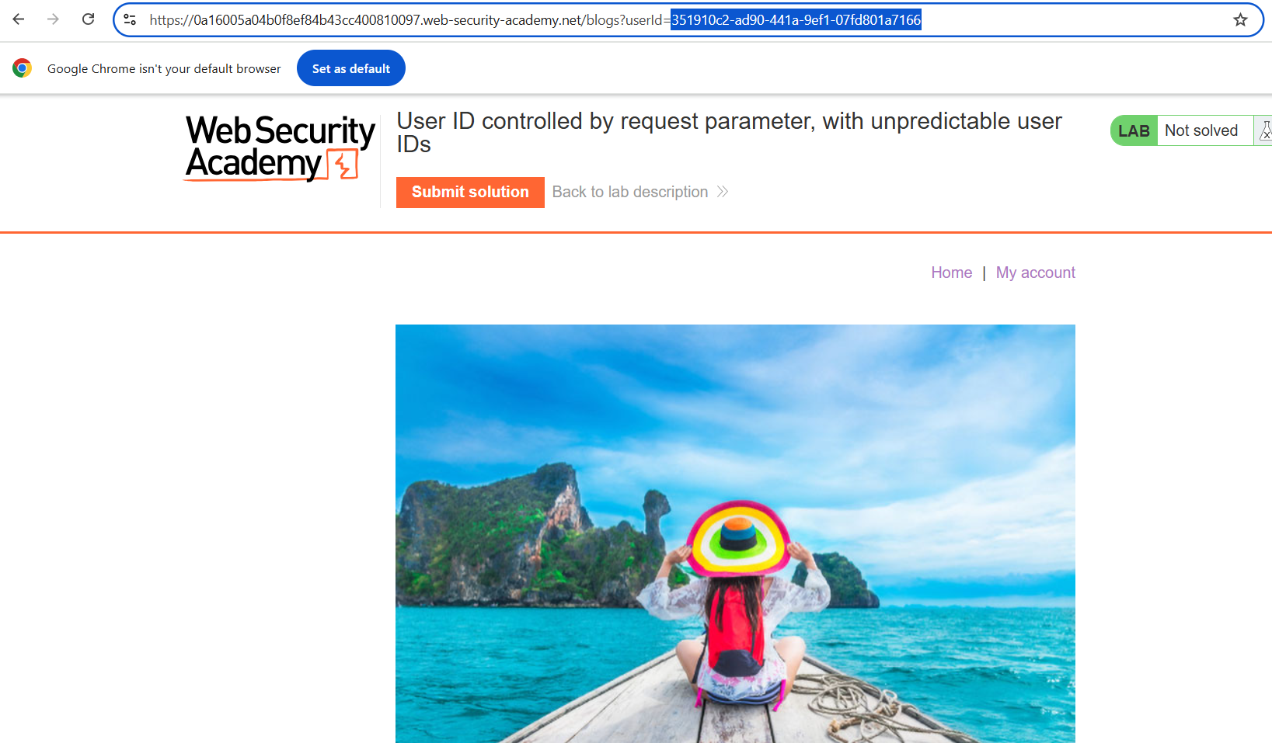

Step 3: Log in as Normal User
Log in using the supplied credentials:
- Username: wiener
- Password: peter
Navigate to the My Account page.
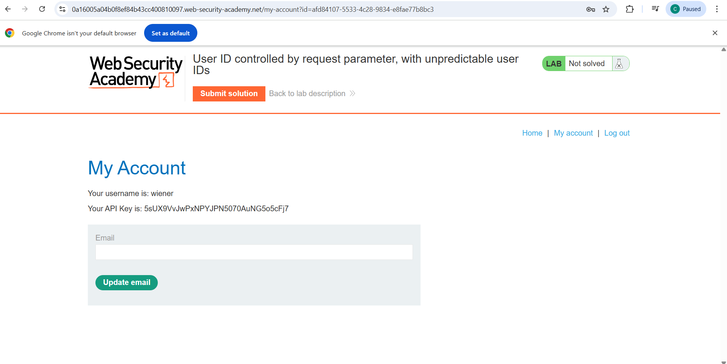

Step 4: Modify the Request Parameter
In the account page URL, replace Wiener’s id parameter with Carlos’s previously captured GUID.
Example:
/account?id=<Carlos_GUID>
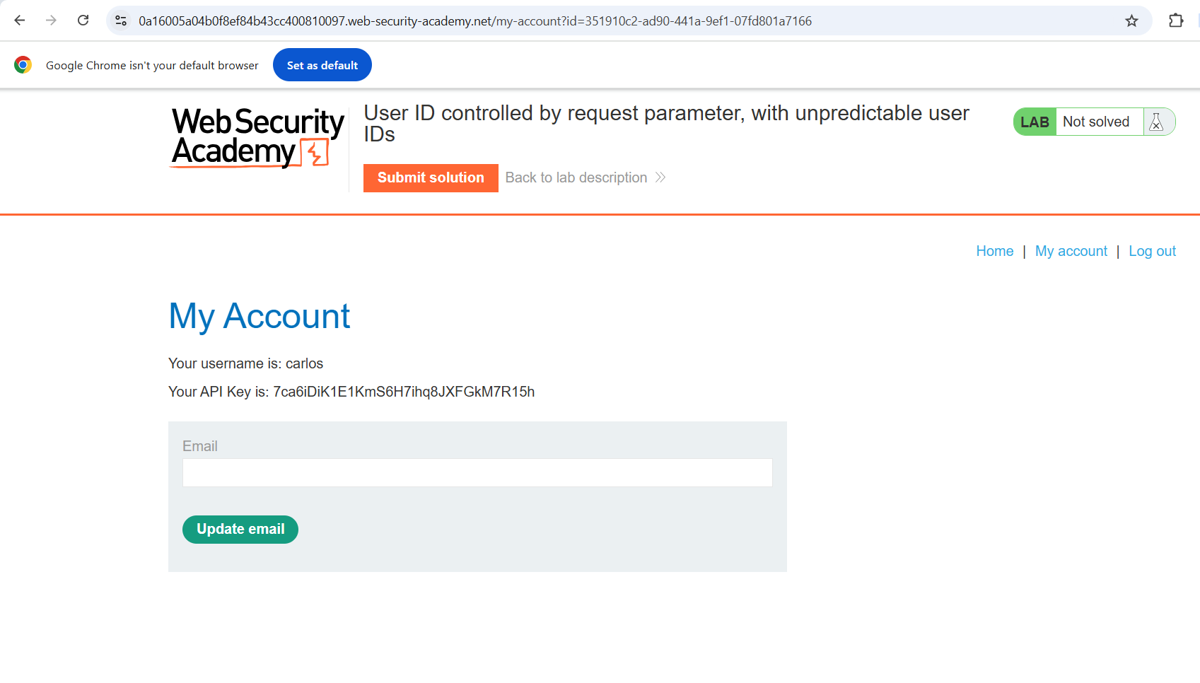

Step 5: Access Unauthorized Data
After modifying the id parameter, the application displays Carlos’s account details, including his API key, without performing proper authorization checks.

Step 6: Submit the API Key
Copy Carlos’s API key and submit it as the lab solution.
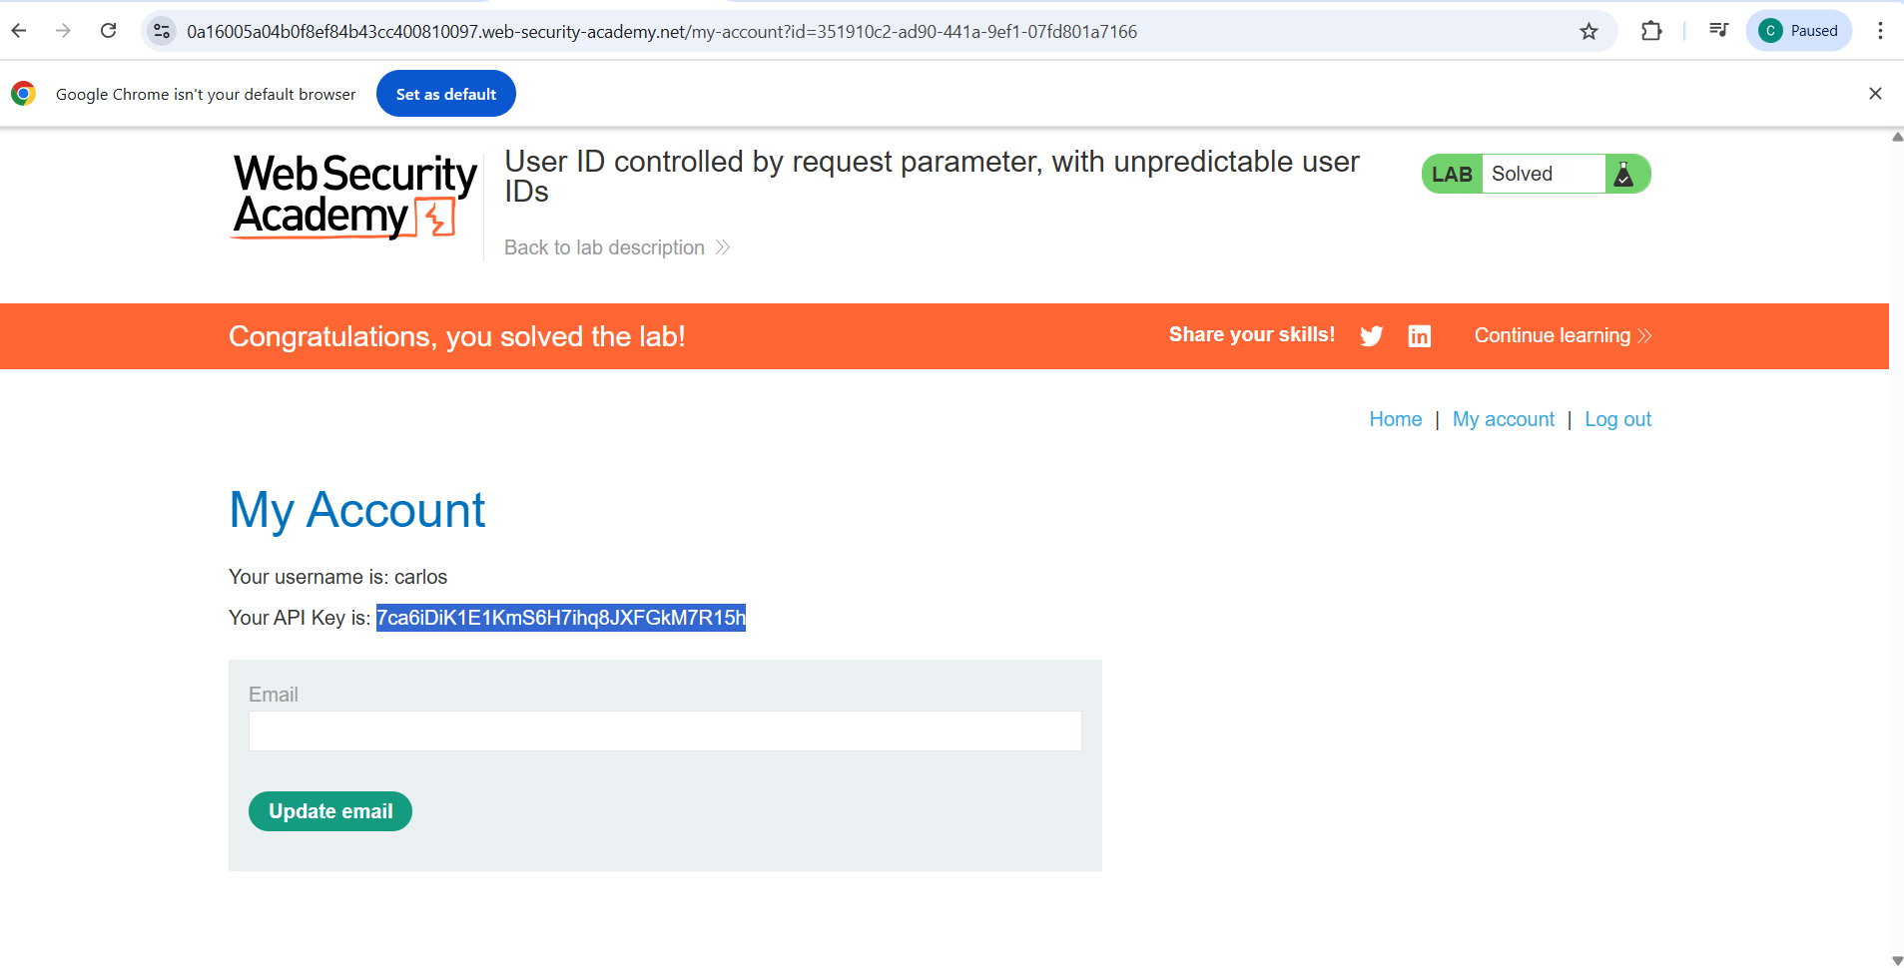

7. Impact Analysis
- Exposure of sensitive user data (API keys)
- Unauthorized access to other user accounts
- Potential account takeover or abuse of APIs

8. Root Cause
The application relies solely on the id request parameter to identify user accounts without validating whether the authenticated user is authorized to access the requested resource.

9. Mitigation & Recommendations
- Enforce strict server-side authorization checks
- Ensure users can only access resources tied to their own session
- Avoid relying on obscurity (GUIDs) as a security control
- Implement access control checks based on authenticated user identity

10. Conclusion
This lab highlights that unpredictable identifiers do not prevent access control vulnerabilities. Proper authorization checks must always be implemented server-side to prevent horizontal privilege escalation attacks.

11. References
- PortSwigger Web Security Academy – Access Control Labs
- OWASP Top 10 – Broken Access Control

12. Author
- Name: Chamika Jayasooriya
- Field: Cybersecurity / Penetration Testing

Repository Usage:
This document is suitable for GitHub portfolios, academic submissions, and cybersecurity internship showcases.

